EXPERIMENT 3
Water Jug Problem
Question
Write a Python program to solve the Water Jug problem .
Aim
To write a Python program to solve the Water Jug problem using the Breadth First Search (BFS) algorithm.
Algorithm
- Start with two empty water jugs.
- Set the capacities of the jugs as 4 litres and 3 litres.
- Define the goal as obtaining 2 litres of water.
- Generate possible operations:
  - Fill the 4-litre jug.
  - Fill the 3-litre jug.
  - Empty the 4-litre jug.
  - Empty the 3-litre jug.
  - Transfer water from one jug to another.
- Store each new state in a queue.
- Check whether the required 2 litres is obtained.
- Continue until the goal state is reached.
- Display the solution.
Code
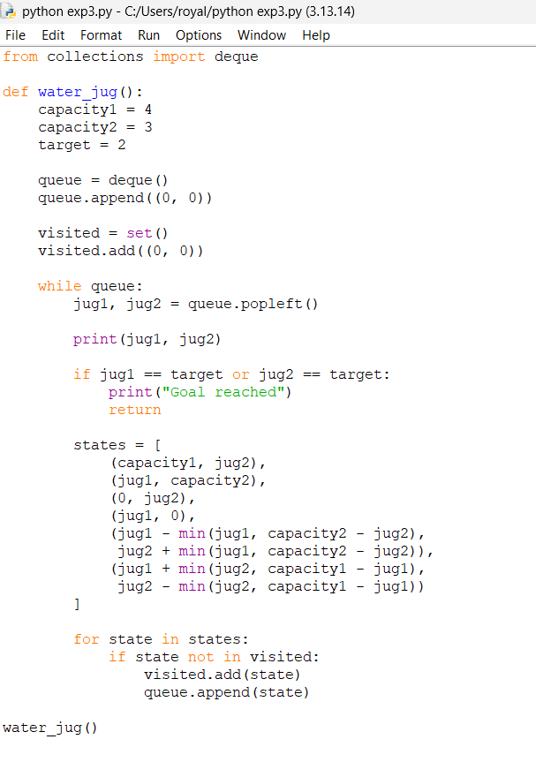

Output
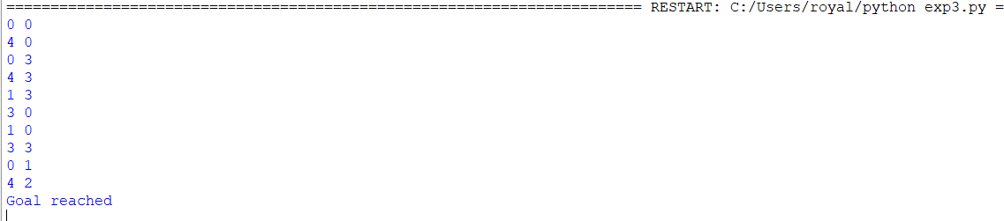

Result
Thus, the Water Jug problem was successfully solved using the Breadth First Search algorithm, and the required 2 litres of water was obtained.

